**Exploring Business Insights through Market Basket Analysis**

**Introduction**

Market basket analysis (MBA) is an important data mining technique that is frequently used in retail and e-commerce to study client buying behavior. MBA finds products that are often purchased together by looking at transactional data. This helps companies with product placement, cross-selling, and customized marketing. This study offers useful insights into customer behavior by illustrating how business data may be applied practically through an MBA.

**Overview of the Dataset**   
Overview of the Dataset: This study's dataset relates to online retail transactions. It contains details like CustomerID, Country, InvoiceNo, StockCode, Description, Quantity, InvoiceDate, and UnitPrice. With information on the products bought, their quantities, prices, customer IDs, and the transaction's nation, each entry represents a distinct transaction.

**Understanding Market Basket Analysis**

Extraction of frequently occurring lot series and association rules from transaction data is a necessary step in market basket analysis. Association rules illustrate linkages between entities based on metrics like result, support, and trust, whereas frequent entities reflect combinations of entities that frequently occur together in events. Leverage quantifies the strength of relationships between goods independent of their individual support, endorsement indicates the frequency of a product, and trust quantifies the likelihood that one product will be purchased when another is.

**Importance of Parameters**

The results of the market basket analysis are significantly affected by the settings of the Apriori algorithm, such as withdrawal, confidence and support criteria. The number of objects found is affected by the support threshold, which determines the minimum frequency required to process a set of objects frequently. Slightly more important items are produced with a higher support threshold, while a lower threshold captures a greater variety of patterns. The purpose of a confidence threshold is to filter out invalid or weak links by defining a minimum confidence level for link rules. By comparing the observed support with the predicted support for independence, the difference threshold assesses the significance of the association rules.

**Exploratory Data Analysis**

The data preparation phase included critical steps to ensure the integrity and relevance of the data set for market basket analysis using the Aprior algorithm. After downloading the data from the OnlineRetail database, various pre-processing steps were performed to clean and structure the data. Concatenation was implemented in the "Description" column to remove leading and trailing spaces, improving consistency in subsequent analyses. Rows with missing values ​​in the InvoiceNo column were deleted to maintain data completeness and accuracy. Additionally, the "InvoiceNo" column has been changed to a string type to ensure consistent data handling across functions. Transactions identified as refunds (marked with C in InvoiceNo) were excluded from the data set, focusing exclusively on positive amounts related to the market basket analysis. These preliminary steps laid a solid foundation for deriving meaningful association rules and actionable insights from event data..

**Application of Market Basket Analysis**

Based on a predetermined support threshold, the event dataset is searched for repeated items using the Apriori algorithm. Then, using the downloaded object sets as a starting point, association rules are created to find meaningful relationships between objects. Higher confidence and height values ​​indicate a stronger relationship between the elements of the association rules evaluated based on these values. Companies can improve product offerings, simplify inventory management, and create targeted marketing campaigns because the identified rules provide actionable insights into customer behaviour.

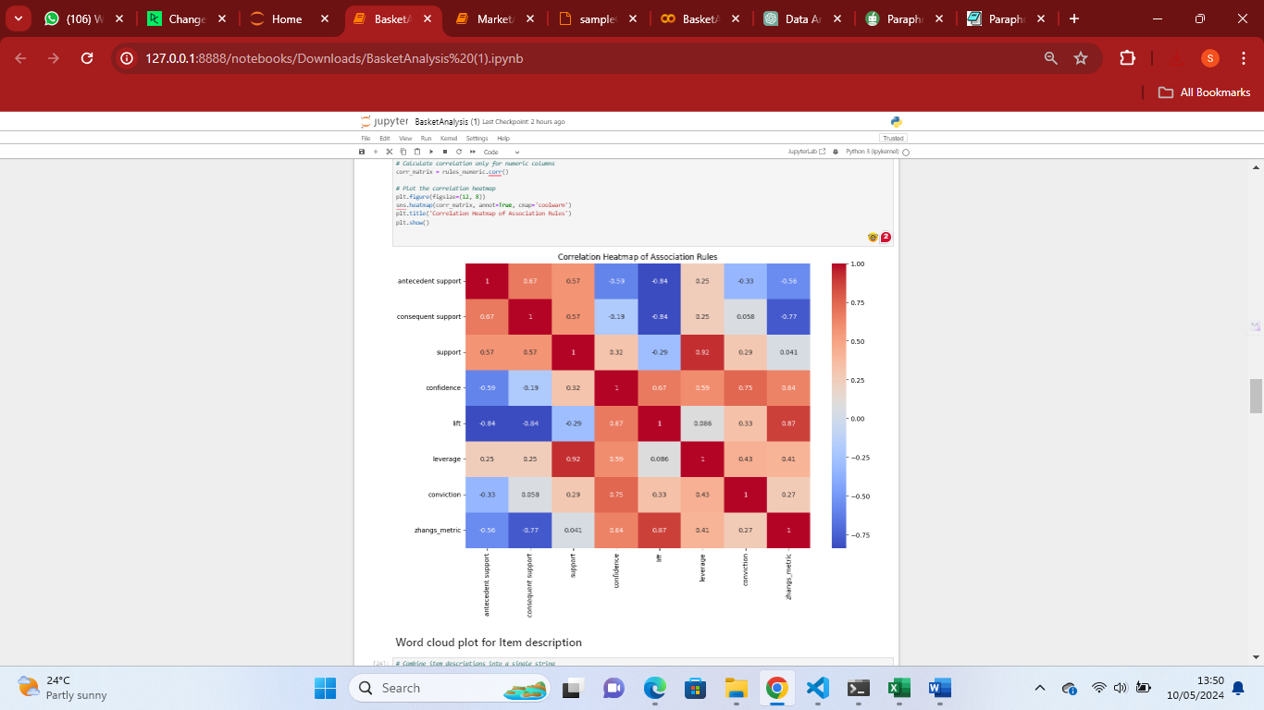

The Apriori algorithm, a classic and powerful MBA method, was used to identify frequent items based on a minimum support threshold of 0.07. This threshold ensures that we focus on items that occur frequently enough to be statistically significant. Association rules were then created using liftometers, which measure the strength of association between objects. To capture significant ratios, we set the minimum lift threshold to 1.

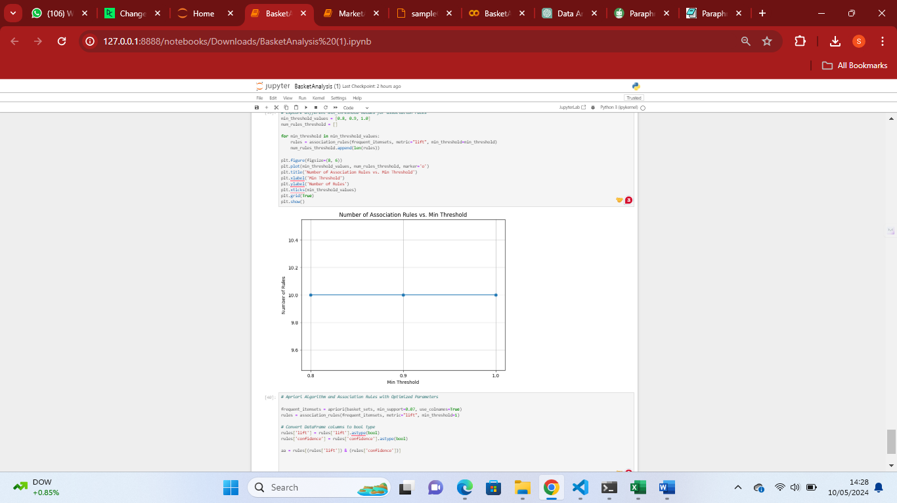

**Parameter Tuning and Analysis**

Examining association rules resulting from regular adjustments of support and confidence levels provides insight into how various factors affect the results of market basket analysis. The focus is on finding thresholds that create a trade-off between relevance and coverage, and trade-offs between rule quality and number are explored by experimenting with different thresholds. Parameter tuning is an important part of market basket analysis because it allows us to tune the model for optimal performance. By examining different minimum supports and designing thresholds, a deeper understanding of how these parameters affect the number and properties of generated association rules is gained. The analysis showed that a minimum gain setting of 6 and a confidence value of 0.8 or higher resulted in a set of targeted association rules with strong statistical significance. This optimization ensures that the rules created are functional and reliable, guiding companies to effective product placement, advertising and customer engagement strategies.

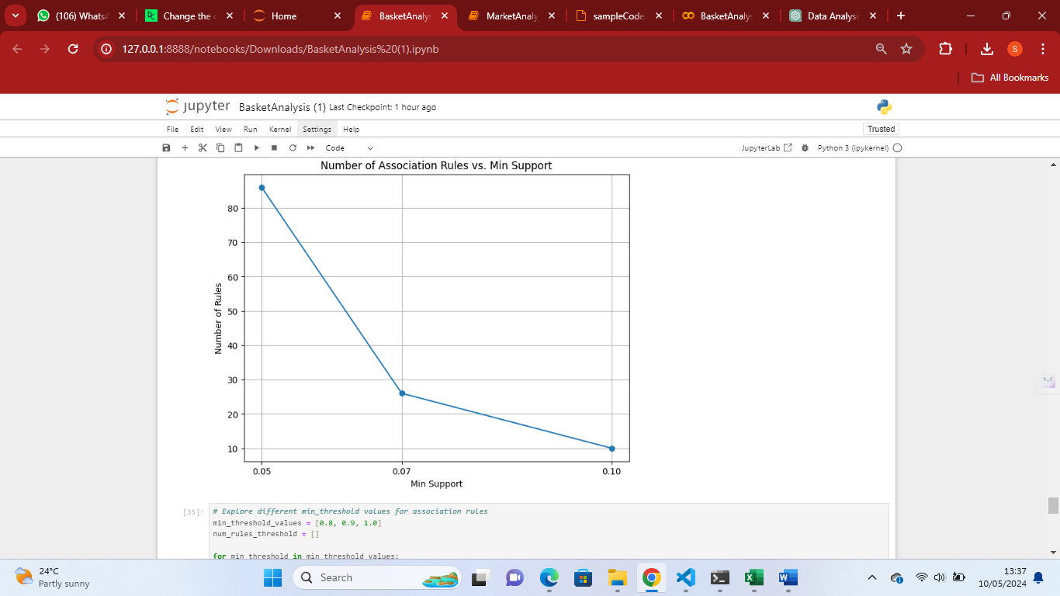

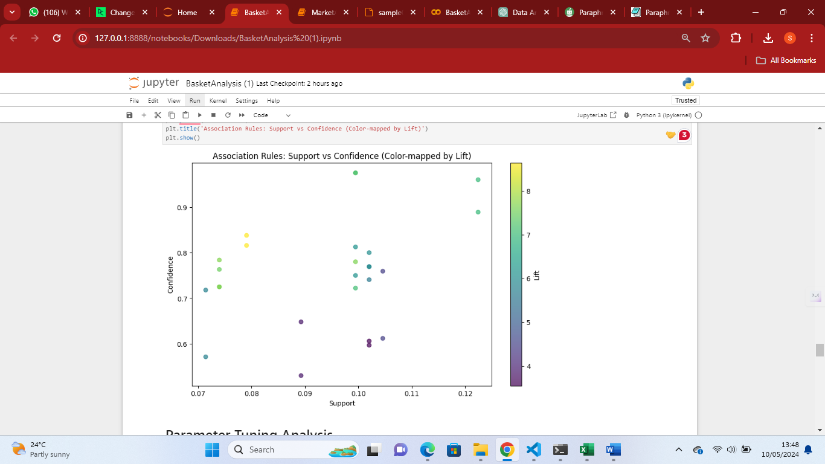

By connecting these findings into previous insights, we find that varying the confidence and support levels permits a more in-depth investigation of the dataset's relationship patterns. More common itemsets and linkages can be found with lower support thresholds, which may also reveal subtle correlations that would have gone unnoticed with larger thresholds. Higher confidence thresholds, on the other hand, highlight stronger correlations, weeding out weaker interactions and offering more trustworthy information for making decisions.

Businesses are able to customize their association rule mining strategy to meet certain goals and preferences by considering the interaction between support, confidence, and the quantity of created rules. When emphasizing the reliability of identified relationships, a higher confidence threshold may be desirable, but a higher support threshold may be appropriate for discovering larger patterns throughout the dataset. In the end, using these insights enables companies to glean actionable knowledge from their data, resulting in better decisions and more focused strategic planning efforts.

**Conclusion**

In summary, market basket analysis powered by algorithms like as Apriori is essential for understanding customer behaviour and directing tactical choices. Businesses may find hidden trends, customize marketing campaigns, improve product offers, and boost operational efficiency by utilizing critical indicators like lift, support, and confidence. This study emphasizes how important market basket analysis is as a technique for increasing corporate value and obtaining a competitive edge in the ever-changing business environment.